**Multisensor Data Collection for Time Sensitive Network**

Ya Wai Thone

Department of Electronics Engineering, Yangon Technological University, Yangon, Myanmar  
[yawaithone@gmail.com](mailto:yawaithone@gmail.com)

*Abstract*— This research explores WSN technology using vehicles with RF modules, cameras, antennas, Raspberry Pi, and an Arduino-based base station. MATLAB supports data storage and real-time decision-making. Machine learning and signal processing algorithms enhance data fusion, while a TSN simulator and deterministic algorithm optimize data collection efficiency, focusing on sensor usage, energy management, and data quality.

Keywords— Wireless sensor network, Arduino, nRF24L01, time-sensitive network (TSN), Data Analysis.

# Introduction

# This research explores WSN technology for vehicle-to-vehicle communication, crucial for intelligent transportation systems. Using an Arduino and nRF24L01 modules, it collects and analyzes real-time data from two vehicles. Objectives include constructing an observer for data collection, analyzing graphical visualizations, and improving data acquisition techniques with indoor/outdoor signal strength evaluation and SPSS analysis.

# SYSTEM ARCHITECTURE AND DESIGN

*A. System Description*

The developed system is designed to collect speed sensor data from two moving vehicles, log the data using Tera Term, and analyze it via SPSS software using the curve estimation technique. The observer, implemented using an Arduino UNO connected with an nRF24L01 module, receives speed data from both vehicles. The speed data is logged into an Excel file, which is then converted to SPSS format for analysis. Fig. 2.1. illustrates the system architecture.

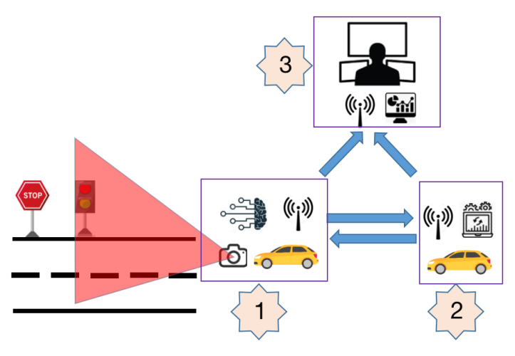

Fig. 2.1. System Architecture of the system

In a connected vehicle setup, the leading vehicle continuously transmits its speed data to both the following vehicle and a base station. The following vehicle alternates between receiving this data and transmitting its own speed data to the base station. The base station remains in receiving mode, collecting speed data from both vehicles, as depicted in Figure 2.2.

The leading vehicle processes vision data from its camera and acknowledgment signals from the following vehicle using machine learning for traffic sign detection and OpenCV for lane centering. It generates steering commands and sends processed sensor data to both the following vehicle and an observer. The following vehicle receives position and IMU sensor data from the leading vehicle, processes it to synchronize its movement, and generates steering commands while transmitting sensor data to the observer. The distance between two vehicles is around 100 cm. The observer collects, visualizes, and stores various sensor data from the vehicles, providing real-time insights into their speed and position within the network.

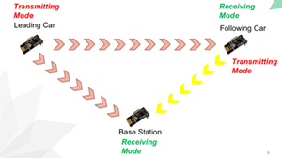

Fig. 2.2. Network Planning diagram

*B. System Components*

The system's core functionality revolves around the observer's construction, which is essential for analyzing graphical visualizations and evaluating estimated equations. The hardware requirements for constructing the observer include: Arduino Uno andNRF24L01 Module

Arduino is an open-source platform widely used for electronics projects. It includes a physical programmable circuit board (microcontroller) and an Integrated Development Environment (IDE) that runs on a computer to write and upload code to the board. The Arduino IDE uses a simplified version of C++, making it accessible for beginners [1].

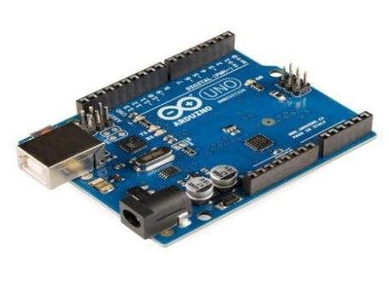

Fig. 2.3. Arduino hardware

The NRF24L01 is a 2.4-2.5 GHz ISM band transceiver module offering programmable output power and frequency channels via SPI. Operating at low current (9.0mA TX, 12.3mA RX), it supports up to 100m communication range and connects to six modules. Compatible with 3.3V and 5V systems, it features 8 pins including CE, CSN, and IRQ, facilitating versatile wireless communication setups with 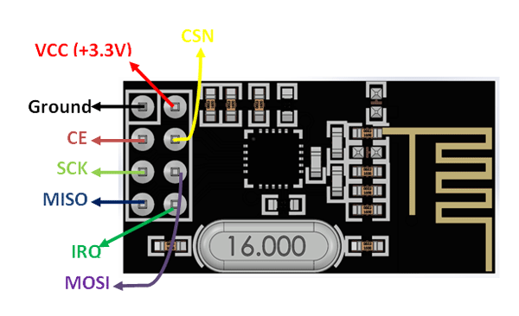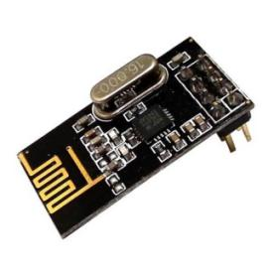bandwidth-efficient channel allocation [2].

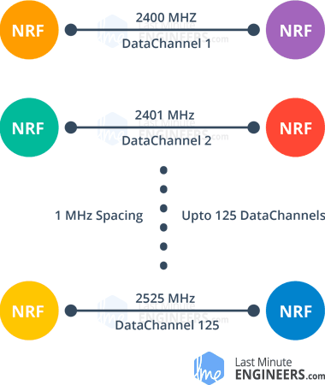Fig. 2.4. Hardware configuration and pinouts of nRF24L01

Fig. 2.5. RF channel frequency

1. *Connection Between NRF24L01 and Arduino*

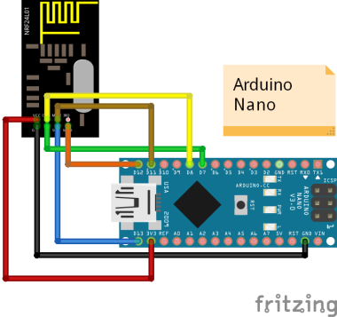The connection between the NRF24L01 module and the Arduino board is crucial. The hardware SPI pins on the microcontroller offer optimal performance for the transceiver module. For Arduino UNO/Nano V3.0, the SPI pins are digital 13 (SCK), 12 (MISO), and 11 (MOSI). For Arduino Mega, the pins are digital 50 (MISO), 51 (MOSI), 52 (SCK), and 53 (SS).

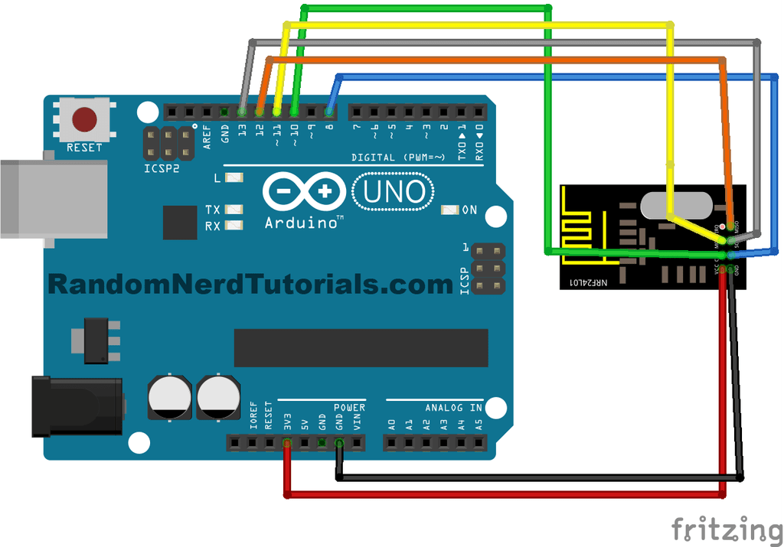

Fig. 2.6. Connection between Arduino (UNO & Nano) and nRF24L01 module.

1. *Working Principle*

After choosing the hardware components, the observer is constructed with selected components. The aim of this system is to collect various sensor data by changing different signposts and locations with two moving vehicles. Figure 2.7 shows the overall block diagram of the observer system. Data sent from two encoders are received by nRF module via Arduino IDE.

nRF 1

(car1)

nRF 2

(car 2)

nRF 3

(base station)

Arduino

Teraterm

Excel

SPSS

|  |  |  |  |  |  |  |  |  |  |
| --- | --- | --- | --- | --- | --- | --- | --- | --- | --- |
|  | Model summary | | | | | Parameter Estimates | | | |
| Equation | R square | F | df1 | df2 | Sig | Constant | b1 | b2 | b3 |
| Linear | .191 | 66.391 | 1 | 281 | .000 | 60.025 | .003 |  |  |
| Logarithmic | - | - | - | - | - | - | - | - |  |
| Quadratic | .540 | 164.532 | 2 | 280 | .000 | 33.632 | .019 | -1.520E-006 |  |
| Cubic | .714 | 232.215 | 3 | 279 | .000 | 12.528 | .045 | -7.733E-006 | 3.951E-010 |
| The indepent variable is seconds. | | | | | | | | | |

Fig. 2.7. Block diagram of the system.

1. METHODOLOGY

In this methodology chapter, SPSS is employed for generating graphical visualizations and estimating equations using curve estimation techniques. The focus is on analyzing data trends through various curve models and their equations. Special attention is given to channel capacity and throughput as key metrics that define the efficiency and performance of the network under study. These analyses provide essential insights into the network's operational capabilities and limitations in real-world scenarios.

1. *Application of Statistical Package for the Social Science*

SPSS, or Statistical Package for the Social Sciences, supports data management and analysis in social science research. It includes tools for basic statistics, predictive modeling, text analytics, and visualization. SPSS facilitates tasks like data transformation, regression analysis, and ANOVA, aiding in understanding data relationships and presenting results effectively [3].

1. *Curve Estimation Technique*

Curve estimation techniques in regression analyze various models (e.g., linear, quadratic) to fit data effectively, illustrated in Figures 3.1 and 3.2. SPSS provides regression statistics like coefficients and R-squared in Figure 3.3, aiding in model assessment and outcome prediction. The process includes simultaneous fitting of multiple datasets and numerical tests such as the approximate F-test and bootstrap confidence intervals in Figure 3.3.

Chart, scatter chart



Fig. 3.1. Chart, scatter chart



Example of curve fit.

Fig. 3.2. Curve models and its equations

Fig. 3.3. Example Result configuration of Curve EstimationUnits

1. *R-square*

The coefficient of determination (R-squared) measures the strength of a regression model, ranging from 0 to 1. A high R-squared indicates less prediction error, but it does not assess the model's overall quality or reliability [4]. Figures 3.4 and 3.5 illustrate its variance explanation and graphical results.

(1)

**Chart



** (2)

Fig. 3.4. Curve interpretation of R-square

Fig. 3.5. Graph Interpretation R-square

1. *F statistic, Degrees of freedom*

"F" is the value of the ANOVA test statistic. The F distribution has two different degrees of freedom: df1 and df2. If both models have the same number of parameters, the formula for the F statistic is.

(3)

where SS1 is the residual sum of squares for the first model and SS2 is the residual sum of squares for the second model. If the models have different numbers of parameters, the formula becomes:

). (4)

Degree of freedom (1) relates to the number of cells means (k) free to vary to achieve the grand mean, which is the mean across all groups and conditions.

Degree of freedom (2) represents the total number of observations (n) minus the number of cells means (k), reflecting how individual observations relate to the cell means [5].

1. TEST AND RESULTS
2. *Preliminary Tests*

In preliminary tests, three nRF modules paired with Arduinos were used to evaluate message transmission and reception. Two transmitters sent messages simultaneously to a single receiver, which successfully identified and displayed each message. Fig.4.1 and 4.2 illustrate the hardware setup and successful message reception, respectively

.

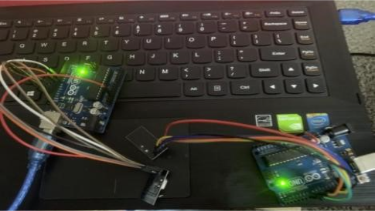

Fig. 4.1. Hardware design for two transmitting & one receiving tests

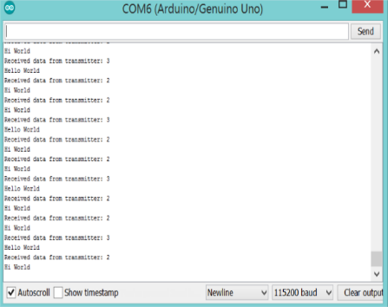

Fig. 4.2. Result of data from two transmitters

1. *Signal Strength Test*

In the second test, the signal strength of nRF24L01 modules was evaluated by varying the distance between the transmitter and receiver. An iOS app measured the distance from the transmitter to the receiver, determining the modules' effective range, which can reach up to 100 meters in open space at a lower baud rate. Figure 4.3 illustrates the app and its configuration.

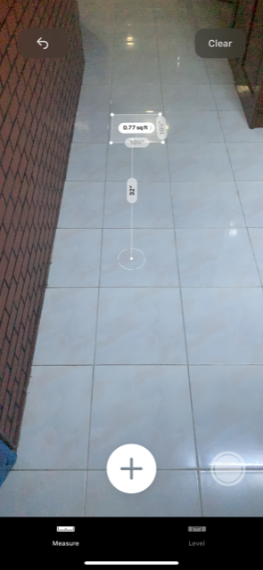

Fig. 4.3. Measure Application and its configuration

Signal strength tests of nRF24L01 modules were conducted in indoor and outdoor environments to evaluate performance variations. Indoors, strong signals were maintained up to 3.5 feet. Outdoors, at MJTDC 2, the module transmitted up to 130 feet, with strong signals up to 75 feet. This demonstrates better performance in open spaces. Findings are shown in Fig 4.4 and 4.5.

Fig 4.4 Result of Signal Strength test Outdoor

Fig. 4.5. Results of Signal Strength test Indoor

1. *Data Collection and Logging*

After completing the preliminary tests, speed data collection commenced, with the data being logged into Excel for subsequent analysis using SPSS software. The data logging was performed using Tera Term software, which automatically saves incoming data in an Excel-compatible .csv format. By selecting the timestamp option, the date and time were recorded as a separate column in the Excel file [6].

1. *Indoor and Outdoor Tests*

In the indoor test (Figure 4.6), speed data from two vehicles were collected over a 15-foot lane in approximately 9 seconds. Over 200 data points were logged in Excel, measuring speeds in cm/s. SPSS software analyzed the data using linear, quadratic, and cubic models for both vehicles, categorized by wheel (right and left). Fig. 4.7,4.8, 4.9 and 4.10 display the results for car1 and car2.

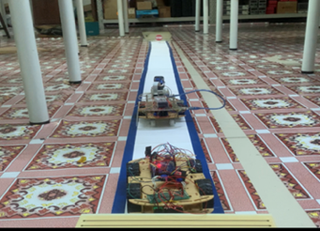

Fig.4.6. Indoor Test

Fig. 4.7 Speed Versus time for right wheel of car1

Fig 4.8 Speed Versus Time for left wheel of car1

Fig 4.9 Speed Versus Time for right wheel of car2

Fig. 4.10. Speed Versus time for left wheel of car2

In an outdoor test (Fig. 4.11), speed data from two vehicles were collected and logged directly into an Excel file. Pre-programmed artificial lanes were utilized in a well-lit location with a smooth surface. The data collection lasted about 9 seconds, yielding over 200 data points. Figures 4.12,4.13,4.14 and 4.15 show SPSS software's curve estimations for the speed data from both vehicles.

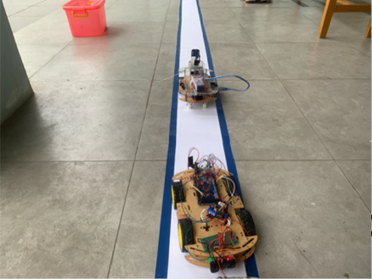

Fig. 4.11 Outdoor Test

Fig. 4.12 Speed Versus time for right wheel of car1

Fig 4.13 Speed Versus Time for left wheel of car 1

Fig. 4.15. Speed Versus time for left wheel of car 1

1. DISCUSSION

The study utilized a WiFi-controlled car to evaluate wireless network throughput indoors and outdoors. Results showed consistent mobile node speeds, slightly lower than theoretical predictions due to factors like friction and environmental conditions. Outdoor speeds were slower due to surface differences. Throughput remained stable but decreased over distance, influenced by interference and network load.

1. CONCLUSION

This study investigates wireless mobile network throughput using a star topology with a WiFi-controlled mobile node equipped with a NodeMCU module and an ultrasonic sensor. Results show consistent throughput decreases as distance from the router increases, yet performance remains stable indoors and outdoors, aligning closely with calculated values, highlighting reliable network operation.

##### References

1. Asadi, F., "Introduction to Arduino Boards," in Essentials of Arduino™ Boards Programming, Maker Innovations Series. Apress, Berkeley, CA,2023.
2. L. B. Wang, C. C. Shen, "Design of Remote Monitoring and Control System Based on NRF24L01 Wireless Communication Module," Applied Mechanics and Materials, vol. 553-562, pp. 3142-3146, 2014.
3. Field, A., Discovering statistics using SPSS (3rd ed.). SAGE Publications Ltd,2009.
4. Montgomery, D. C., Peck, E. A., & Vining, G. G., Introduction to linear regression analysis (5th ed.). Wiley,2012
5. Hair, J. F., Black, W. C., Babin, B. J., & Anderson, R. E., **Multivariate Data Analysis** (7th ed.). Pearson, 2014.
6. Kostas, N., Koutsopoulos, K., Tsiropoulou, E. E., & Polyzos, G. C., Wireless data logging and real-time analytics for road traffic monitoring. IEEE Transactions on Intelligent Transportation Systems, 18(6), 1587-1598, 2017.

Fig 4.14 Speed Versus Time for right wheel of car 2